The Ultrasonic Transducer Transmitter and Receiver

To My Valued Customers:
I’d like to take a second before I start to say thank you to all that chose to shop at the HobbyTronixStore. It is a small business that I run on the side, and it’s good to know that in these poor economic times, there are still people out there who share the same interest and passion towards electronics that I have. Thanks to all of you. I hope you find this document useful.

Sincerely,
Patrick Mitchell
Electronics Engineering Technician
HobbyTronixStore - www.electroniclessons.com

LET’S GET STARTED!
Okay! So in every electronic circuit, there must be a power supply, correct? Well in this care we’re going to need three different supplies. Don’t worry, you’re not going to really need three different sources of power. Only two. First of all, we’re going to construct our power supply for the ultrasonic transmitter circuit. As you can see below, all we need is a 9v battery/connector (Fully charged battery), and two capacitors. Now, if you’re using a battery, you don’t necessarily need the two capacitors. It’s just good practice to implement them. If you’re using another source of power; perhaps an AC to DC wall transformer, which I don’t suggest you do, then the capacitors are a very good idea. I greatly advise that you use batteries for this project.. That being said, the power supply circuit is really up to you. You can customize it, and go all out with protection and what not. However, if you’re taking my advice, and using a 9v battery, I wouldn’t worry too much about noise effecting the performance. We have to worry more about noise at the receiver than we do at the transmitter, so don’t waste too much time worrying about it. I don’t suggest using a power supply larger than 9VDC. If you decide to use a wall transformer, I suggest actually testing the output value with a multi-meter before using it. I’ve found several wall transformers that are rated to output 9VDC, and actually output 12-15VDC, so beware.
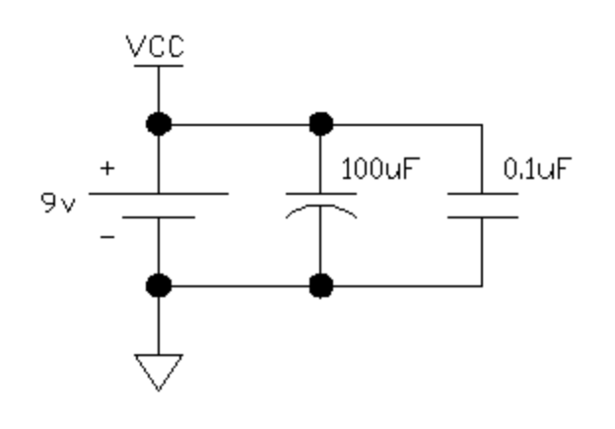
THE TRANSMITTER CIRCUIT
The really neat thing about these transducers is the fact that they are designed to transmit and receive. If you have two ultrasonic transducers, you can send and receive. Of course you’ll need two breadboards or two PCBs. Let’s talk about the transmitter, shall we? I have personally tested these transducers are frequencies as low as 20kHz, to as high as 50kHz. You can still transmit and receive information at these frequencies, despite the fact that the center frequency is 40kHz.

On the following page, you’ll see a diagram for the transmitter circuit. I’ve offered a part list, but there are many passive component values (resistors/capacitors/transistors) that can be modified to achieve maximum output power. The part list I am offering is a “safe” list of components to use. By this, I mean I’ve used these components to go in conjunction with my video advertisement. That’s right! The components I’ve listed here, are the components you saw in my video. Note that this not my most efficient circuit for transmitting/receiving, but it is good for beginners, and those who are simply a little rusty. The receiver circuit can be modified greatly as well. Anyhow, back to the transmitter.

Perhaps you’ve noticed by looking at the diagram that the transmitter circuit is fairly simple. We really only have a few blocks of information to discuss. Let’s start with out 555 timer oscillator. For those of you who are new to the 555 timer, we’ve got our 555 timer configured in astable mode; an oscillator. By this, it is meant that we will be using this chip to create our transmission frequency. If you google search “555 timer calculator” you can determine which components you’re going to need to create certain frequencies. The components that determine the frequency and duty cycle of the 555 timer in astable mode are the following:
R5 = RA; R6 = RB; C1 = C
Now, you have the option of placing a 0.01uF tantalum or ceramic capacitor between pin#5 and the ground line, but it is not necessary. This would be used in higher frequency applications. You may get a slightly better resolution if you implement this capacitor, but I did not use it, so I will not be adding this component to the parts list.

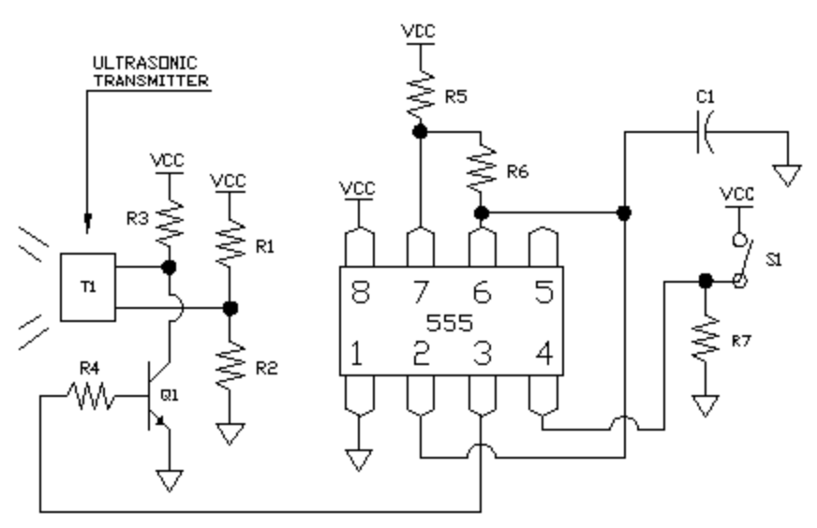
Pin#4 of the 555 timer is the reset pin. R7 is placed between pin#4 of the 555 timer, and ground. We also have a single pull single throw switch connected to pin#4 and the VCC line. This circuit acts to ground the reset pin by default through the use of a pull-down resistor (R7), which will disable the output (pin#3). When we press our SPST switch (on/off switch), VCC will be applied to pin#4 thereby activating the output of the 555 timer. In other words, when we press the button, we are transmitting. When the normally-open button is not being pushed, the unit is in idle mode, and is not transmitting.

One of the two transducer pins is connected to a voltage divider circuit (R1/R2). The second pin is connected to R3, which is also connected to the VCC line. The second pin of the transducer is also connected to the collector of a low-power NPN transistor. The emitter is connected to the ground line. You can use just about any low- power NPN transistor for this. I used the 2N2222, but you can use just about any low-power transistor, as long as it is NPN. If you use a PNP, you’re going to lose a lot more power in Idle mode, as the value for R3 is very small, and is in parallel with the 555 timer circuit and the voltage divider circuit when the output of the 555 timer is high (activating the transistor). The resistor between the 555 timer output (R4), which is pin#3, and the base of the NPN transistor is extremely important. Don’t forget to use it.

TESTING THE TRANSMITTER:
I sure hope you have an oscilloscope. If you don’t then I hope you have been careful in making your connections. Please refer to the transmitter diagram on the previous page.

1) With your oscilloscope, probe the following areas while pressing down the transmit button.
- Pin#3 of the 555 timer.
- The first pin of the transducer; the pin connected to the middle of the voltage divider.
- The second pin of the transducer that is connected to R3, and the collector of the NPN transistor.

You should see a waveform on your oscilloscope screen at each of these test points. THEY WILL NOT ALL LOOK THE SAME. Your main point of interest is the pin of the transducer that is connected to R3 and the NPN transistor. Are you able to see a decent waveform here? If not, then you may have a problem. If so, you should be ready to move on to the receiver.

2) If you are not getting anything at either of the pins of the transducer, then check your connections. If you are not detecting any waveform coming from your 555 timer, then go back and check your connections again. Your 555 timer should be working perfectly. Is your 555 timer properly grounded? Is it properly powered by the 9v VCC line?

3) Is your battery sufficient? Perhaps you’re better off going to your nearest grocery store and purchasing a 9v Duracell or energizer battery.

4) If all else fails, and you’re not able to find the problem, start over. Remove all of your connections, and start from scratch. Don’t feel bad if this is the case. I’ve had to do it a hundred time in the past. Sometimes it’s just what you may need. I’ve personally re-created this circuit using this guide.

TIME TO TALK ABOUT OUR RECEIVER CIRCUIT
A warning to those of you who may have had a little bit of trouble with the transmitter circuit: The receiver is only as hard as you make it. Take your time and make sure you care making all the right connections. The receiver circuit is substantially more complicated.

Now, since we’re starting a whole different circuit, we’re going to need another power supply. I earlier mentioned that we’re going to need three power supplies in total. What I really meant by this was that we’re going to need to step down our 9v (battery) source by using a voltage regulator circuit. We only want to work with 5v in this circuit. Don’t use 9v or you’ll destroy the TTL components. Here is the schematic for the power supply.
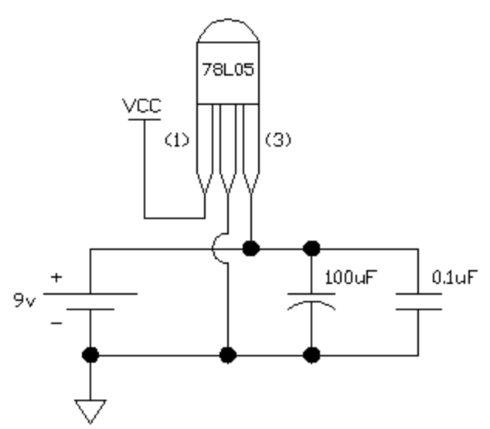

So let’s have a chat about this power supply circuit. As before, the capacitors are not necessary if you’re using a 9v battery, as batteries are primarily stable. We want to connect the positive lead of our 9v battery to pin#3 of a 78L05 5v regulator. If you decide to use an LM7805 regulator instead, make sure you google the data sheet, as the pin-out is reversed. We want to connect the negative lead of our battery to the middle pin of the 78L05 as well. Pin#1 should then read 5VDC. Make sure you check for 5v at pin#1 using a multi-meter once you’ve made all your power supply connections. This 5VDC line will be our circuit VCC.

I’ve broken up the receiver circuit into three separate schematic diagrams. If you have an oscilloscope, you can test each section of the circuit. Let’s talk about the first schematic, which can be seen below.

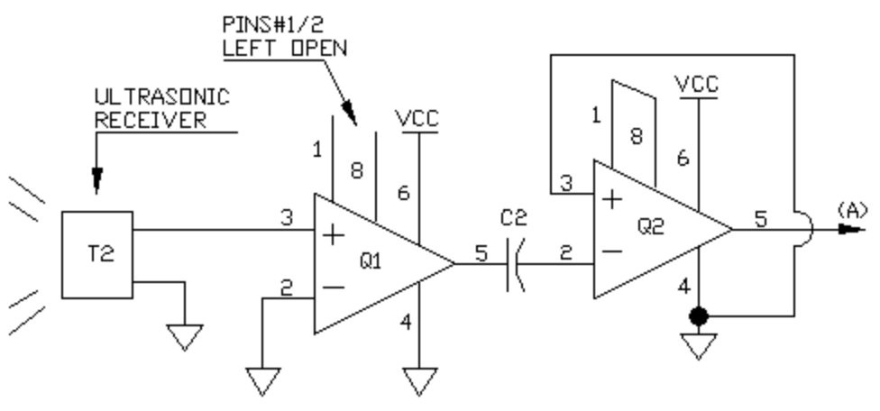
As you may well know, the ultrasonic transducer can be used to either transmit or receive signals. We use the same type of transducer for the receiver than we do for the transmitter. What we have here is a two-stage active amplifier. We’re using the LM386 for this. The LM386 is an 8-pin DIP chip that has one medium power amplifier per chip. It is commonly used in older audio amplifier circuits. The gain is decided by the connections made at pins 1 and 8. As you can see, in the first stage we leave these pins open. This will offer us a gain of 50. This means that our incoming signal that is coming from the transmitter will be amplified 50 times. Pin#6 is the VCC pin of the LM386, and pin#4 is the ground pin. Make sure that the negative input (-), which is pin#2, is connected properly to the ground line. Pin#3, which is the positive input will be connected to the first pin of the ultrasonic transducer. Ground the second pin of the transducer.

IMPORTANT NOTE:
It is a good idea to decouple each of the chips in this project with 0.1uF capacitors. If you’re not familiar with this term, it means that you should place a 0.1uF capacitor between the VCC pins and the ground pins (In this case, pins 6 and 4). This will help eliminate excess noise that may occur within the circuit. I’m not going to add these in to the schematics or parts list, as they are optional. However, it is highly advised that you make this a common practice.

The output of the first stage (Pin#5) is then coupled to the negative (-) input of the second stage amplifier. We’re using a coupling capacitor here to get rid of the DC component. This is very important! We just want to amplify the signal. As well, make sure you connect the capacitor the right way. Do not place the negative end of the capacitor to the output of the first stage. Make sure that the positive lead of the capacitor is connected to the output of the first stage. The positive input (+) of the second stage amplifier is connected to ground. Note that pins 1 and 8 are tied together. This is done to maximize the voltage gain. When you connect these pins together, you get a voltage gain of 200. So far we have the original signal being received from the transducer being multiplied by 50 at the first stage. The amplified signal coupled from the first stage is then amplified 200 times by the second amplifier. Make sure to make all the connections on the second LM386. They are all the same, or at least similar to the first stage connections.
The output signal of the second amplifier is labeled as (A). Read on.

THE SECOND RECEIVER SCHEMATIC
Alright. We have what looks to be another amplifier stage, but really it acts as both an amplifier, as well as a noise eliminator. For those of you who have a strong background in electronics, you may scoff at that statement, but hear me out. Since we’ve amplified the incoming signal so much, we’ve also significantly amplified ambient signals that we’re picked up by the transducer. We could implement filters, but we can work around these signals, as these signals are not common noise. After the second stage, we get an ambient signal that ranges between 0-2v in amplitude. This is why we’re going to employ a comparator circuit. We can tune out these ambient signals, and concentrate on the transmitted signal using this circuit

HOW IT WORKS:
When we have a strong signal being amplified by the two-stage active amplifier circuit, the output of the second stage should be saturating. By this, it is meant that we should be getting what looks like a square wave from the second amplifier when a strong signal is being received. Since we’re powering our amplifiers with a power source of 5VDC, the maximum output will be about 80% of 5VDC. This means that the output is saturating. The amplifier may want to output a higher voltage, but it is limited, leaving us with what looks like a square wave. So we have roughly a 0-4.5 volt signal at the positive input of the comparator (the third LM386, which is Q3) when we are receiving a strong signal from the transmitter.

The tuning is accomplished by the use of a potentiometer (P1). Since the ambient signals being picked up are ranging between roughly 0-2v, we can manually set the negative input (-) of the comparator to just about this voltage amplitude. This will keep the output of the comparator at roughly 0v until a strong signal (2-5v) is amplified by the amplifier stages. I realize this may be hard to grasp if you’re relatively new to electronics, but if you have an oscilloscope, you can leave the output of the second stage unloaded, and you can probe it with an oscilloscope to view the ambient signal. The middle pin of your potentiometer is the wiper. The wiper is the pin that is attached to the negative input (-) of the comparator. With the potentiometer, we can set the voltage at the negative input to any voltage between 0v and VCC, which in this case is 0-5VDC.
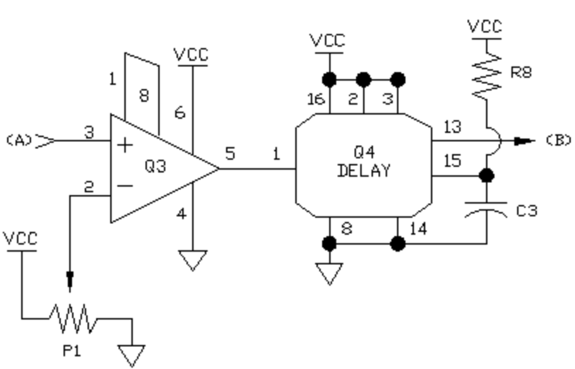
TUNING:
So let’s get tuning. You don’t necessarily need to do this now, but why not get a head start? Probe the output of the comparator once you’ve set up the entire comparator circuit and connected signal (A) to the positive input. Plug in your battery, and watch the output of the comparator with your oscilloscope. What you may want to do is actually tune down the voltage at the negative input using the potentiometer, to see an amplified ambient signal at the output. From there, we can tune the voltage at the negative input up slowly, until the output is a flat 0v. To reiterate, you will see a messy square wave at the output of the comparator when the voltage at the negative input is below the ambient signal level. We want to slowly tune the voltage at the negative input up until it is just over the ambient signal voltage amplitude. When this is accomplished, we should see a smooth 0v at the output of the comparator. Now, once you’ve done that, use your transmitting transducer circuit to send a signal into the receiver transducer. Tune it so that you can receive a strong signal from as far away as possible without allowing the comparator to be overcome with the ambient signal. Experiment with it. It may take a little time to understand what I’m talking about. Experimentation is the key to learning. Keep that in mind, my friends.

THE DELAY:
You’ll have to scroll back to the previous page, to refer to the delay circuit. For the delay, I’ve chosen to use a 74LS123 TTL chip. This chip is a re-trigger-able monostable multivibrator. This chip is a 16 pin DIP IC. It has two internal retrigger-able monostable multivibrators. We are only going to use one. The idea is this. We are working with higher frequencies in this project. We will soon be working with a circuit that will require single pulses to operate properly. This means that we have to turn several thousand pulses (the kHz signal coming from the transmitter) into a single pulse. The 74LS123 acts to do just that. Once a digital signal triggers the input (Pin#1), the output activates (turns from 0-5v), and a delay will begin. The delay is determined by R8 and C3. This delay time is roughly 1/5 of a second in it’s current configuration. Feel free to experiment with different values. If the delay starts, and another pulse hits the input pin, then the delay starts over. When the transmitter stops pulsing, the signal at the input pin will stop, and when the delay runs out, the output of the 74LS123 turns off. Hence turning thousands of pulses into a single pulse.

If you cannot yet grasp this concept, play around with this chip. You’ll come to understand the chip. Read the data sheet if you wish. Make absolutely sure that you’ve properly made each of the required connections, or else your circuit will not work. The output signal of the 74LS123 (Pin#13) is labeled as (B). We will be using this signal line for our last circuit.

THE FLIP-FLOP TOGGLE SWITCH
Finally! This is the last circuit required to finish this project. Keep in mind that the circuit can be used for tons of things. You just need to continue it as you see fit. You can use the toggled output of this circuit for tons of things. Let me introduce you to the flip-flop toggle switch.

The final chip we’re going to employ is the 74LS109A dual PGT JK flip flop DIP IC. This means that we have two flip flops within the IC, and they are activated on the positive rising edge of the incoming waveform. We have it configured as a toggle switch. Every time the rising edge of a waveform hits the CLK input (Pin#4), the Q output will toggle either from off to on, or from on to off. We want our circuit to start in a known state. By this, I mean that I want my Q output to be off when I power on my receiver circuit. For this, we require what is called a power on reset circuit
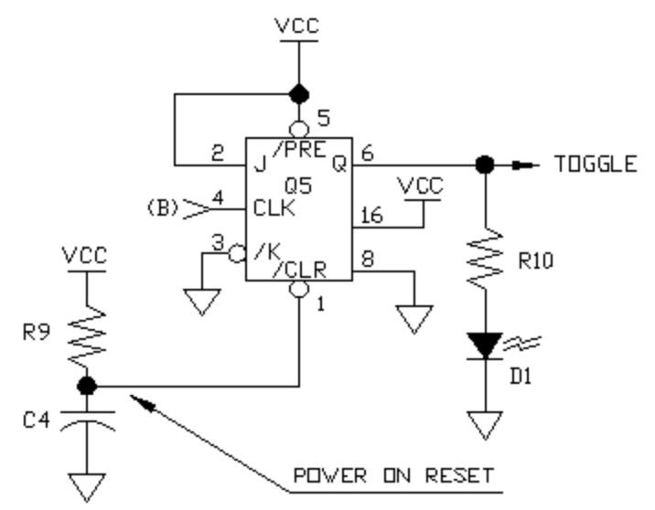
THE POWER ON RESET:
The use of a resistor and a capacitor allows us to create a short delay. As you can see, pin#1, which is the asynchronous input /CLR, is connected to an RC network. The resistor acts to slow the current that will be collected by the capacitor. This means that the capacitor will take time to charge from 0-5v. When the capacitor charges past roughly 2.8 volts, the flip flop will act as a toggle switch. However, in the time it takes for the capacitor to charge to roughly 2.8v, the /CLR input will regard the voltage at the capacitor as low logic, which forces the Q output low. Only when each of the inputs (/PRE^/CLR^J^K) are at 5v, or high logic, will the 74LS109A act as a toggle switch. To reiterate, when the /CLR input is low, the Q output will be low. After the capacitor is charged, the circuit goes into operational mode. We need this circuit because when power is initially applied, our flip flop may not turn on in the right state. It may start with the Q output turned on (high logic). We don’t want this. As well, the other chips may be fidgety when power is first applied. Make sure you employ this circuit.

Pin#16 is the VCC pin, and pin#8 is the ground pin. The Q output is tied to a current-limiting resistor (R10), which is in series with an LED (D1), and ground. From here, you can do with this signal as you will. Interface it with a microcontroller, turn on a relay, activate another circuit, etc. The possibilities are endless.

TEST TIPS:
You may want to play around with the resistor/capacitor values for the 74LS123 monostable multivibrator delay. You can customize your delay. You may want to do this to make the toggle switching a little more comfortable. It’s all a matter of testing, and more importantly, understanding. The hardest concept you may have to conquer is the monostable multivibrator. You can also play around with your Power-On-Reset resistor/capacitor network. You don’t need to, but you can minimize the time needed for the POR if you wish. You can also feel free to change the transmission frequency. It’s all about how you want to do it!

PARTS LIST
MISC:
78L05 - 5v regulator
LM555 - 555 timer
R1 - 220R
R2 - 220R
R3 -390R
R4 - 5k6
R5 - 1k8
R6 - 1k8
R7 - 10k
R8 - 100k
R9 - 10k
R10 - 470R
C1 - 0.01uF
C2 - 10uF
C3 - 10uF
C4 - 10uF
S1 - SPST
D1 - Red LED
Q1 - 2N2222
T1 - DPU1640AOH12C
T2 - DPU1640AOH12C
Q1 - LM386
Q2 - LM386
Q3 - LM386
Q4 - 74LS123
Q5 - 74LS109A

